**ANNUAL BONUS REPORT**

**Challenge** :- It’s EOFY and that means time for annual bonuses !

The Store operates in three regions and only the top performing employee in each region qualifies for a bonus. Find out Which three employees are eligible to get bonuses for this year.

**Note** :- Employees are measured on total sales($$)

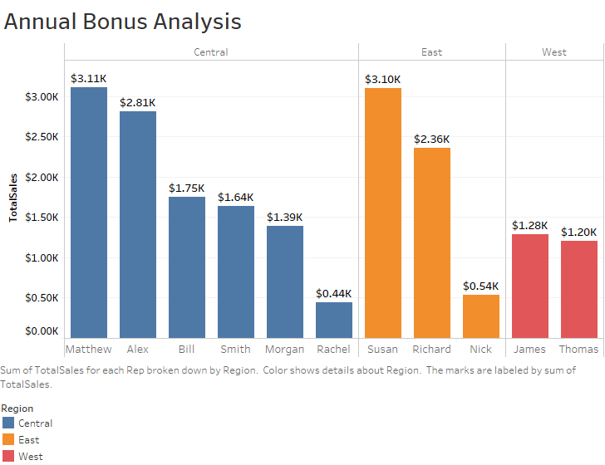

* **From this visualization we can say that Matthew from Central, Susan from East and James from West regions are eligible to get bonuses for this year.**